For: ENG 315-45
From:
Subject: The Importance of Color in Interior Design
Date: May 18, 2017

One of the most economical means of transforming interior spaces into having more aesthetic appeal is by use of colors. Over the years, I have researched this topic and performed projects involving it. In doing this I have found that using a color wheel and color disc are very helpful in refreshing the rooms of my home. I last used them when I was painting as an essential tool. Which this tool is commonly used by any paint pros everywhere, the color wheel is helpful to see the relationships between different hues.
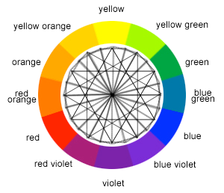
Knowing how and why colors blend or clash, and which color combinations work and which don't, can mean the difference between creating a décor that pleases the eye and enhances the spirit and one that jars the senses.
In this report, I’ll teach you how to use these two tools and others, with the result that you’ll make your interior spaces feel larger and more warm and inviting.
Here’s what I’ll cover:
o Deciding on your interior colors based on your personality
o Understanding the effects of using additive colors
o Understanding the effects of using subtractive colors
o Putting it all together

Deciding on your interior colors based on your personality
An interior space should be designed to feel welcoming, comfortable and appealing to the individuals utilizing the space. The impression created should therefore be appealing and satisfactory to the viewer’s eye. If wrong choices of colors are utilized in an interior space, it might seem more unpleasing both aesthetically and to the function set for the interior space. For example, there’s nothing wrong with using white as a predominant color in a living space but it can be overwhelming unless you layer other shades of white or gray in the room, or make liberal use of contrasting accent colors. It might be a better choice to “open up” hallways or smaller rooms or to provide the clean feeling desirable in a bathroom.
Therefore, the basic way to improve and transform interior space is by improving the appearance of the space. For example, select color combinations that harmonize well with each other and flow from room to room. So if you can see your dining room from the kitchen, paint each room the same neutral color, varying shades of that color, or in coordinating colors. I personally did this in my home and the results were outstanding. In this case, color can be used to enhance the look of interior space, it may also be used to make small spaces appear larger and vice versa.
I as an aspiring artist, as well as interior, commercial and landscape designers have long known the importance of choosing harmonious color combinations, and one of the most important tools we've used in selecting colors is the Color Wheel theory.
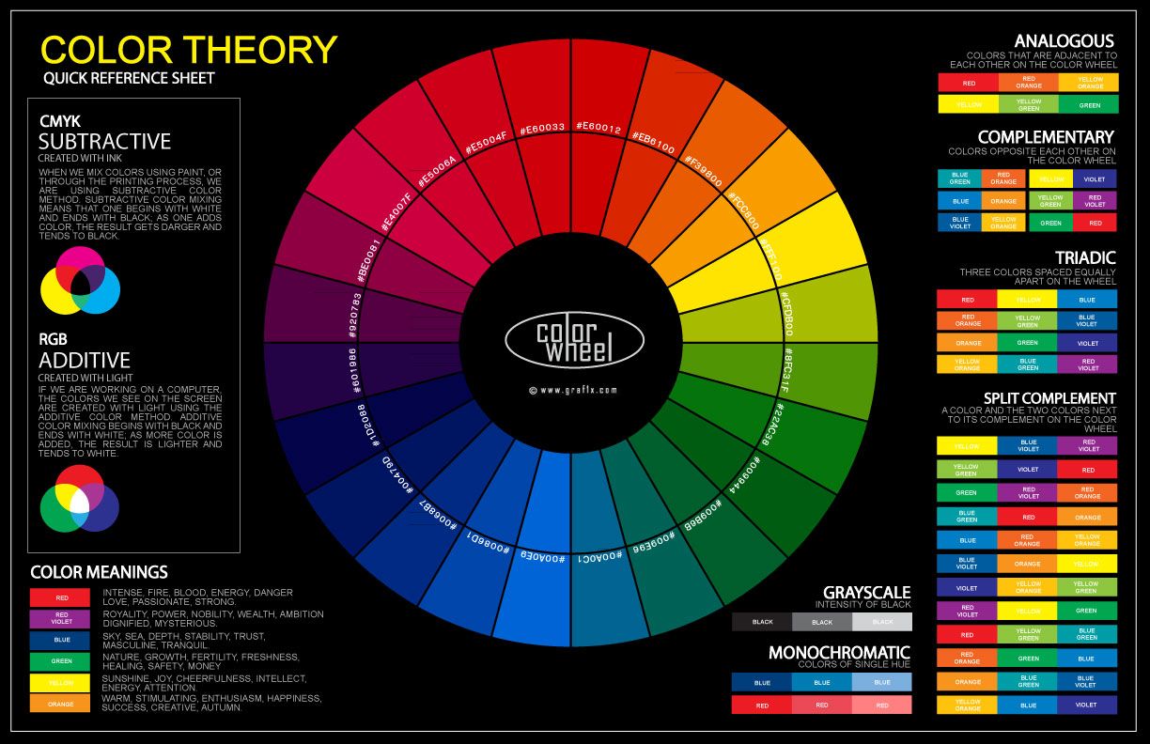

Understanding the effects of using additive colors
An additive color describes the outcome of mixing colored light. The three primary colors are additive primaries and any other color formed as a result of their mixture is referred to as additive colors. Therefore, additive colors used for interior spaces may include: Yellow, it is achieved by mixing red color with green color. Purple, it is arrived at by mixing Red color with green color. Additive colors have an aesthetic appeal that makes interior spaces look more fancy and attractive. Combined with other lighting methods, they add value to the items placed in an interior space. They could be suitable for Lounges, baby shops and coffee shops (Pile & John, 1998).
Subtractive Colors
The concept of these colors is that the object of use either absorbs or subtracts all colors apart from the color of the object. This is basically the color we see. For instance, a red object attracts all colors and reflects back only red: the same applies to yellow and blue. These colors are more suitable for interiors spaces such as: Hospitals, Blue color is preferred for hospitals. It absorbs all colors and reflects back only red. It therefore creates a cool mood of the hospital environment. Yellow color absorbs no colors but reflects back all the colors in an interior space. Yellow is therefore suitable to enhance the items placed in interior. It could be suitable for sitting rooms, lounges and clubs. It could also be used for baby shops and baby room to create an exciting mood. White is also another subtractive color (Taylor, 2000).
White color is achieved by mixing all the three primary additives which are red, green and blue. In this case, white absorbs all colors of the surrounding interior and reflects back all the colors from the interior. It therefore creates a perfect setting to enhance the items placed in an interior space. It makes small spaces appear larger and also adds value to the items placed within the interior. In conclusion color is an important element in adding value and transforming interior spaces (Taylor, 2000).
References:
Lesley Taylor, (2000). “Design and Decorative Interiors”. New Holland Publishers (UK) Ltd.
Pile,John F. (1998). “Interior Design”. Harry N. Abrams, Inc., New York

